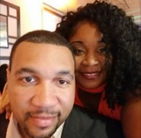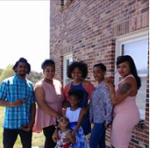

My Story
My name is Michelle Powell. I am a mother of 5 children and 1 grandchild. I am married to a wonderful supportive husband, who has taught me what true love is by not only telling me, but, showing me. My children are very supportive and we have a wonderful relationship. With all that being said, I felt there was still a problem that seemed to be deep rooted. With all my husband's love, he couldn't fix it. With all my children's love, they couldn't fix it. I turned to the Lord, and all though I had a relationship with Him, He couldn't fix it because, I wasn't allowing Him to.

I would only allow Jesus certain access to my heart but, not all of it. I wasn't truly free! Instead I turned to food because, it understood me. It wasn't until I met my Pastor of Love Oasis Ministries Billy Dee Williams and his wife a beautiful woman of God Elite Lady Tanisha Williams and her mother Barbara Hayes, did that all begin to change for me. They helped me deal with the matter of the heart of my issue, one that was deep routed. It was then that I began the journey of becoming free and this allowed God to heal me of my wombs and scars. It is then, that I truly begin to love myself again and realize my dreams again and that I do matter. It was like a cloud was lifted and I could see clearly now. It is my desire to pay it forward. To show others, that it's ok to love, believe, hope, and dream again. But, know this, you must get to the root of your issue for your process of becoming free can be effective. Also, who are you connected to. Make sure the people you are connected to are positive. God has sent me a wonderful support system in my friends who push, encourage, and uplift me and one another. If you say, "I don't have that" well, now you do.
Welcome to the start of a new you, my friend!

