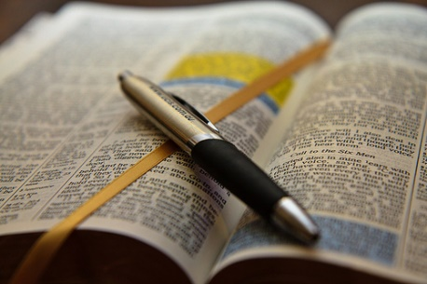

Speaking positive over yourself doesn't always come easy, especially when you are not sure of what to say. Here you will find confessions you can say over yourself as a prayer, that will help bring faith and confidence. It will even help you trust in the Lord with anything you may be facing, whether it is financial, health, or family related.

Confessions

Confession for Pastor & Church

Father, in the Name of Jesus, I thank You that I am fully persuaded by Your Word. I know who I am and what I am capable of doing. I am a new creature, predestined for greatness. I am loved by You, God, regardless of how I perform. I take the shield of faith and quench every fiery dart of the wicked and cast down every thought of insignificance, inferiority, insensitivity, intimidation and insufficiency with the Word of God. The fear of lack is broken and has no power over me. I choose to win in every situation and I am passionate about my future and the future of my church, my children and my career. I believe You are faithful to every promise You've made. You promised no weapon formed against me will prosper. You promised You would deliver me out of all my troubles. You promised You already bore every sickness in Your own body on the tree and with Your stripes, I am healed. You promised You would increase me more and more.

You promised You would daily load me with benefits. I believe what You promised and I am winning over all obstacles, defeats, disappointments and setbacks. I see my future through the eyes of faith, my future looks better than my past my best days are ahead I boldly declare I am anointed to prosper my eyes are open to see creative ways to increase financially. My ears are open to hear the best deals and my heart is pure so that You can channel finances through me. I am on the winning path of supernatural abundance and I live in daily expectation of increase. My winning attitude attracts resources to win in every area of my life. I love the church You have set me in and I decree my pastor opens his/her mouth boldly and makes known the mysteries of the gospel.

I commit to support my church in every vision assignment because I am set in my church as it pleases You. I chose not to allow others to pull me out of my set place of unity. I have made a vow and paid my vow; therefore, I can now decree a thing and it is established unto me. I decree my church has supernatural supply in finances and in people. I believe You are drawing souls to our church from the north, east, west and south, in Jesus' name!!!

Confessions Of Favor

In the Name of Jesus, I am the righteousness of God. therefore, I am entitled to covenant Kindness and covenant favor. The favor of God is among the righteous. The favor of God surrounds me everywhere I go and in everything I do.

I expect the favor of God to be in full manifestation in my life. Never again will I be without the favor of God. It rests richly upon me. It profusely abounds in me. I am a part of the generation that is experiencing God's favor immeasurably, limitlessly, and surpassingly. therefore, favor produces supernatural increase, promotion, restoration, honor, increased assets, greater victories, recognition, prominence, preferential treatment, petitions granted, policies and rules changed and battles won in which I do not have to fight. the favor of God is on me and goes before.

Therefore, my life will never be the same. This is the time of Gods favor in my life. That is the favor of God. In Jesus Name. Amen!

Faith Confession

In the name of Jesus, I am a believer. I believe God's Word. I am what the Word
says I am. I have what the Word says I have. I can do what the Word says I can do.
In Jesus' name, I render ineffective every negative word I have spoken, every negative thing I have thought, every word and thought that has been contrary to the truth of God's Word.

From this moment forward, I will acknowledge only the good
things that are in me in Christ Jesus. I am saying it now: out of the good treasure of my heart, only good things will come to pass. I am the righteousness of God, a new
creation, an heir of God, and a joint- heir with Jesus. I have been delivered from the power of darkness and translated into the Kingdom of God's Dear Son. I have been redeemed by the blood of the Lamb - redeemed from the curse of the Law;
redeemed from sickness and disease, poverty and death. I can do all things through Christ who strengthens me. I am more than a conqueror. He never leaves me nor forsakes me. Since the

Greater One dwells within me, I can overcome every situation. The faith of God resides within me, and through it I have the victory that overcomes the world.
I thank you, Father, that I can have all these things. I believe
it in my heart. I have released it with my mouth. So be it. It will surely come to pass, in Jesus' name, Amen!

